**Polymorphism and virtual function**

**LAB # 08**

** Fall 2019**

**Fall 2021**

**CSE208L Object oriented programming**

Submitted by: **Ashfaq Ahmad**

Registration No. : **19PWCSE1795**

Class Section: **B**

“On my honor, as student of University of Engineering and Technology, I have neither given nor received unauthorized assistance on this academic work.”

Student Signature: ______________

Submitted to:

**Engr. Sumayyea salahuddin**

February 2, 2021

**Department of Computer Systems Engineering**

**University of Engineering and Technology, Peshawar**

**Activity 8.4.1:**

Define an abstract base class **shape** that include protected data membersfor area and volume shape ……………………..

#include<iostream>

using namespace std;

class shape

{

protected:

int var1,var2;

public:

virtual void show()=0;

virtual double area()

{

}

virtual double volume()

{

}

};

class point:public shape

{

protected:

int var3,var4;

public:

point() {

var3 = 0;

var4 = 0;

}

point(int var5,int var6)

{

var3 =var5;

var4 = var6;

}

void show()

{

cout<<"\nPoint X="<<var3;

cout<<"\nPoint Y="<<var4;

}

};

class circle:public point

{

protected:

int radius;

public:

double area()

{

var1 =3.14*radius*radius;

return var1;

}

void show()

{

cout<<"\nPoint X of Circle: "<<var3<<"\nPoint Y of Circle :"<<var4<<"\nRadius of Circle :"<<radius;

cout<<"\nArea of Circle: "<<area()<<endl;

}

circle():point()

{

radius=0;

var3=0;

var4=0;

}

circle(int var7, int var8, int var9):point()

{

var3 = var7;

var4 = var8;

radius= var9;

}

};

class cylinder:public circle

{

protected:

int hieght;

public:

void show()

{

cout<<"\nPoint X of Cylinder: "<<var3<<"\nPoint Y of Cylinder :"<<var4<<"\nRadius of Cylinder :"<<radius<<"\nhieght of cylinder :"<<hieght<<endl;

cout<<"\n Area of cylinder :"<<area()<<endl;

cout<<"\n Volume of cylinder :"<<volume()<<endl;

}

cylinder()

{

hieght=0;

radius=0;

var3=0;

var4=0;

}

cylinder(int var10,int var11,int var12,int var13)

{

var3 = var10;

var4 = var11;

radius=var12;

hieght=var13;

}

double area()

{

var1=(2*3.14*radius)*(radius + hieght);

return var1;

}

double volume()

{

var2=3.14*(radius * radius)*hieght;

return var2;

}

};

int main()

{

shape * ptr;

cylinder Cylinder(6,62,95,4);

ptr = &Cylinder;

ptr->show();

point Point(79, 26);

ptr = &Point;

ptr->show();

circle Circle(33,83,8);

ptr = &Circle;

ptr->show();

}

**Compilation and debugging:**

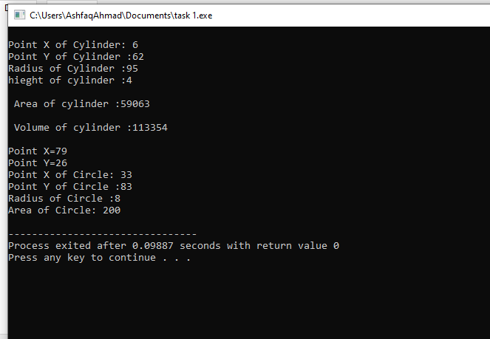

***THE END***